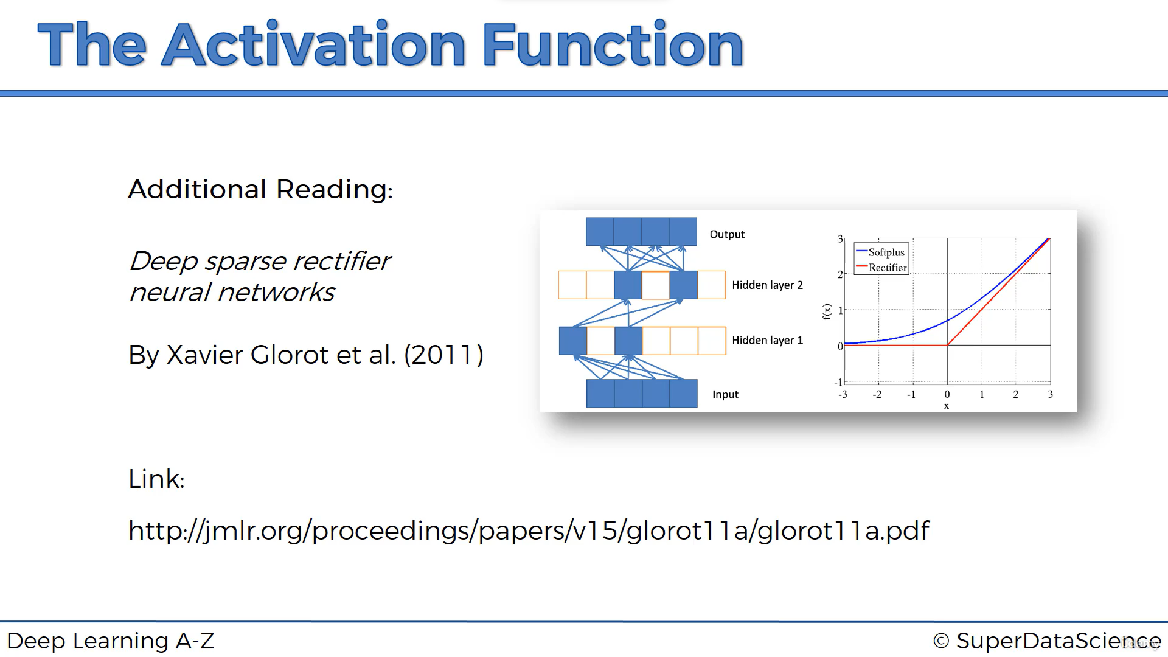

<https://www.superdatascience.com/blogs/the-ultimate-guide-to-artificial-neural-networks-ann>

<https://www.youtube.com/watch?v=Bw7pAYv6iaM>

<https://www.tfcertification.com/pages/deep-learning>

<http://neuralnetworksanddeeplearning.com/chap1.html>

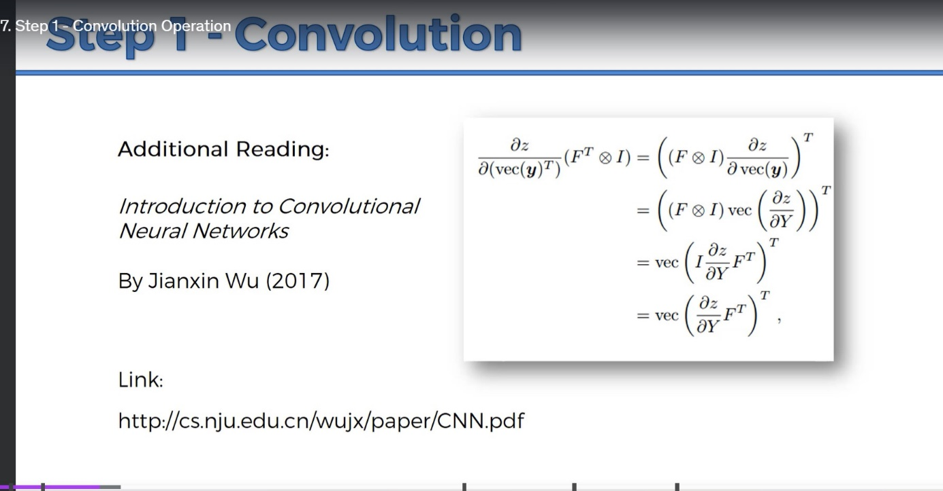

<https://www.superdatascience.com/blogs/the-ultimate-guide-to-recurrent-neural-networks-rnn>

